**iRevolution: A Data-driven Exploration of Apple's iPhone Impact in India using Tableau**

**1.INTRODUCTION:**

**1.1 Project Overview:**

iRevolution is a data analytics project aimed at understanding the market dynamics, consumer preferences, and cultural influence of Apple’s iPhone in India. By leveraging real-world smartphone datasets and powerful visualization tools like Tableau, the project offers a deep dive into how the iPhone brand performs across pricing, specifications, and user engagement dimensions.

The core goal is to equip consumers, marketers, and analysts with intuitive dashboards that simplify complex data into actionable insights. The visualizations explore trends in sales, specifications, battery types, pricing, and model-wise market share, making it easier to compare iPhones with other brands and identify what drives buyer decisions.

**1.2 Purpose:**

The purpose of this project is to analyze and visualize the growing impact of Apple's iPhone in the Indian smartphone market using a data-driven approach. By collecting, cleaning, and presenting real-time data through interactive Tableau dashboards, the project aims to help users:

* Understand iPhone market trends and customer preferences
* Compare iPhone specifications with competing brands
* Identify factors influencing pricing, performance, and popularity
* Support informed purchase decisions through visual insights

This project bridges the gap between raw market data and user-friendly visual narratives, empowering both consumers and analysts to explore insights with clarity and confidence.

**2. IDEATION PHASE:**

**2.1 Problem Statement:**

In India’s rapidly evolving smartphone market, consumers are overwhelmed by a vast array of models, specifications, and price points. Despite Apple’s strong brand presence, there is limited data-driven insight available to help users compare iPhone models with competing smartphones, understand price trends, or make informed purchase decisions.Additionally, industry stakeholders lack an intuitive, visual platform to analyze user preferences, market penetration, and the cultural impact of iPhone adoption in India.

This project addresses the need for a clear, interactive, and insightful dashboard that transforms complex smartphone data into actionable intelligence — empowering users, businesses, and analysts to navigate the iPhone ecosystem more effectively.

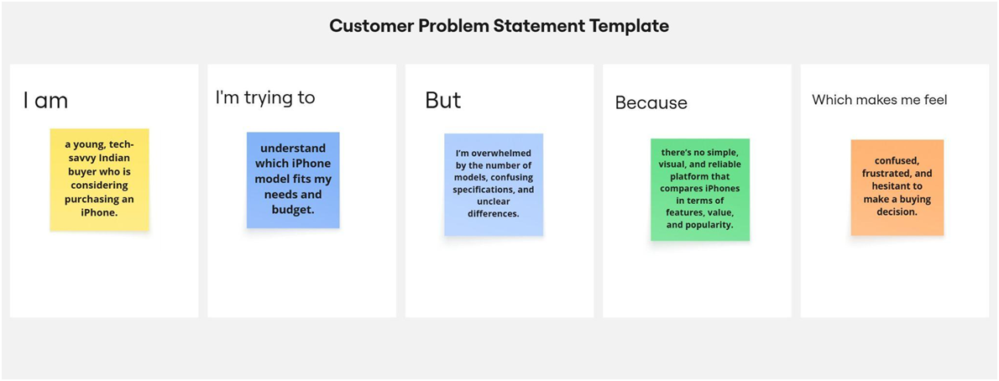

**2.2 Empathy Map Canvas:**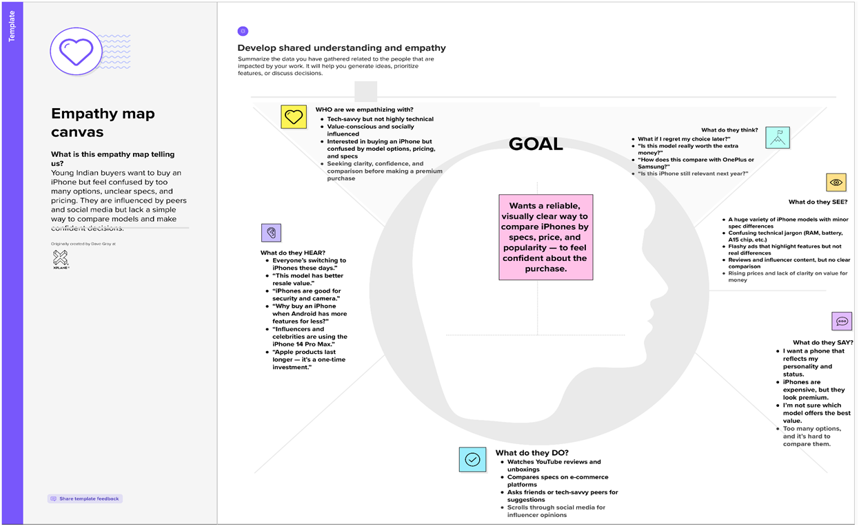

**2.3 Brainstorming:**

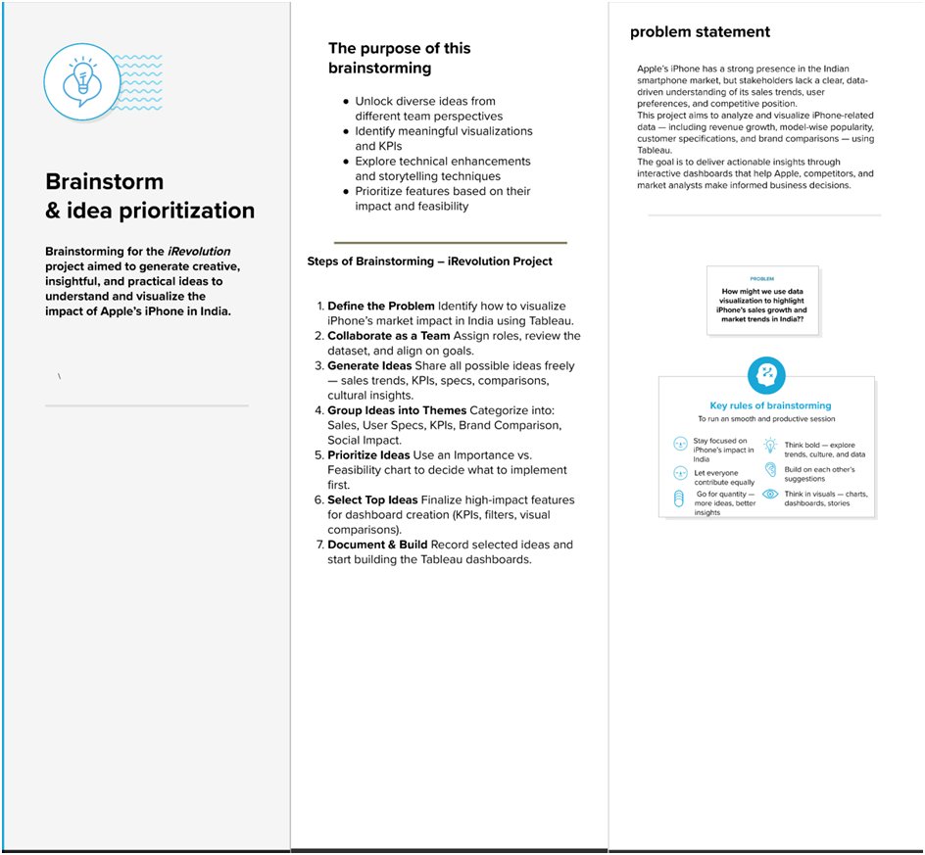

**3.REQUIREMENT ANALYSIS:**

**3.1 Customer Journey map:**

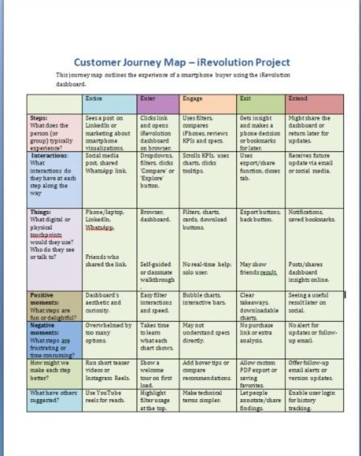

**3.2 Solution Requirement:**

| **S.No.** | **Requirement Type** | **Description** |
| --- | --- | --- |
| **1** | **Functional** | **Load and clean smartphone dataset (brand, specs, price, rating).** |
| **2** | **Functional** | **Enable users to filter phones by attributes like price, RAM, battery, brand.** |
| **3** | **Functional** | **Visualize KPIs such as units sold, revenue, and average sale price.** |
| **4** | **Functional** | **Provide comparison of iPhone models with other smartphones (e.g., specs chart).** |
| **5** | **Functional** | **Embed Tableau dashboards in a responsive web interface using Flask.** |
| **6** | **Functional** | **Design an interactive story with multiple Tableau dashboards.** |
| **7** | **Non-Functional** | **Dashboard should be user-friendly and responsive on both desktop and mobile.** |
| **8** | **Non-Functional** | **Data must be preprocessed to ensure fast loading and smooth filtering.** |
| **9** | **Non-Functional** | **System should be available 24/7 via Tableau Public.** |
| **10** | **Non-Functional** | **Should support scalability for additional brands or data fields.** |
| **11** | **Non-Functional** | **Secure handling of data with limited edit access for end-users.** |
| **12** | **Non-Functional** | **Visuals must load within 2–3 seconds on standard internet speed.** |

**3.3 Data Flow Diagram:**

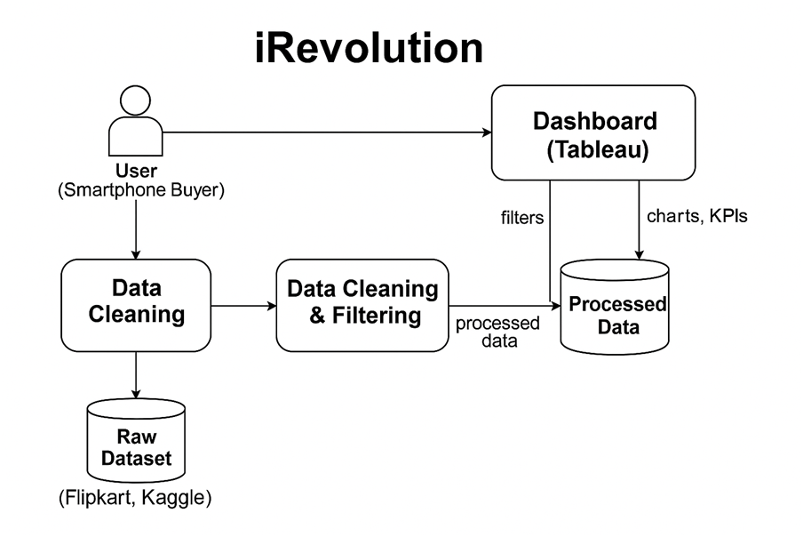

**3.4 Technology Stack:**

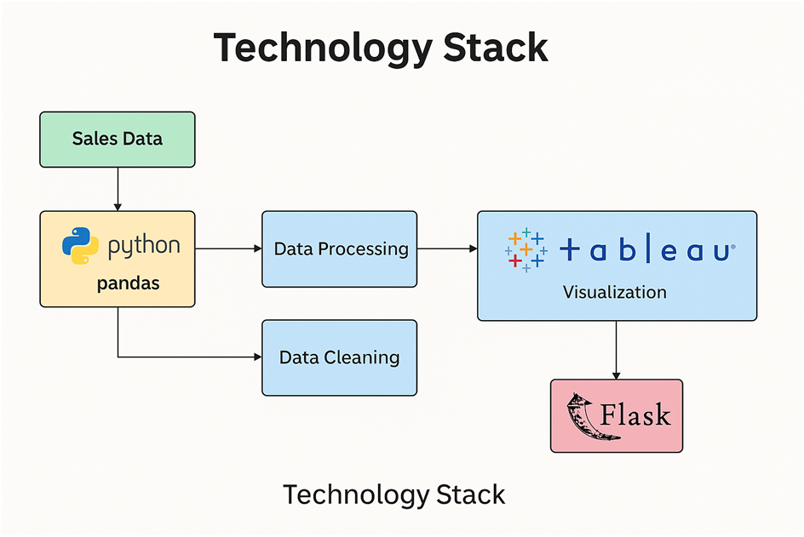

**4. PROJECT DESIGN:**

**4.1 Problem Solution Fit:**

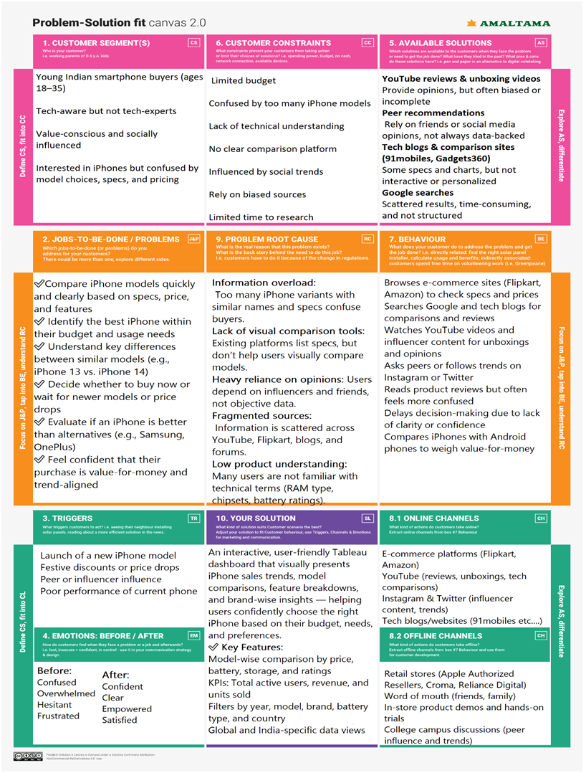

**4.2 Proposed Solution:**

| **S.No.** | **Parameter** | **Description** |
| --- | --- | --- |
| **1** | **Problem Statement (Problem to be**  **solved)** | **Young Indian smartphone buyers are confused by too many iPhone options, unclear specs, and scattered information. They lack a simple, visual, and data-driven tool to compare models and make confident purchase decisions.** |
| **2** | **Idea / Solution description** | **We propose an interactive Tableau dashboard that visualizes iPhone model comparisons, sales trends, KPIs (active users, revenue, units sold), and filters by model, battery type, brand, and country. It helps users make smarter, data-backed purchasing decisions.** |
| **3** | **Novelty / Uniqueness** | **Unlike static review platforms or biased videos, our dashboard offers a clean, unbiased, and visual comparison tool. It combines real data with interactive elements to simplify complex buying decisions — all in one place.** |
| **4** | **Social Impact / Customer Satisfaction** | **The solution empowers users with clear insights, reducing confusion, regret, and reliance on marketing. It supports smarter buying habits, digital awareness, and improves overall satisfaction for tech consumers.** |
| **5** | **Business Model (Revenue Model)** | **The dashboard can be integrated into e-commerce platforms or tech blogs and monetized via:**  **● Affiliate links to iPhone listings ● Sponsored model placements ● Premium dashboard access for in-depth analytics** |
| **6** | **Scalability of the Solution** | **The solution is scalable to:**  **● Other smartphone brands (Samsung, OnePlus, etc.) ● Other product categories (laptops, tablets) ● Regional languages for wider accessibility ● Integration into mobile apps or product recommendation engines** |

**4.3 Solution Architecture:**

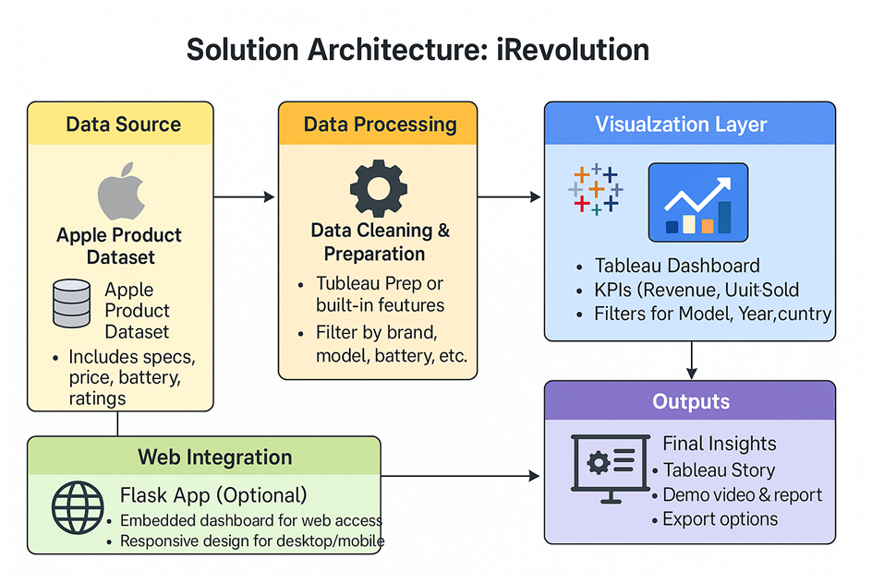

**5. PROJECT PLANNING & SCHEDULING:**

**5.1 Project Planning:**

| **Sprint** | **FunctionalRequirement (Epic)** | **User Story**  **Number** | **User Story / Task** | **Story Points** | **Priority** | **Team**  **Members** |
| --- | --- | --- | --- | --- | --- | --- |
| **Sprint-1** | **Data Exploration**   |  | | --- |      |  | | --- | | **USN-1** | **As a smartphone buyer, I can explore all available iPhone models to understand my options.** | **2** | **High** | **swathi** |
| **Sprint-1** | **Smart Filtering**   |  | | --- |      |  | | --- | | **USN-2** | **As a user, I will receive confirmation email once.I have registered for the application** | **3** | **High** | **swathi** |
| **Sprint 1** | **Model Comparison**   |  | | --- |      |  | | --- | | **USN-3** | **As a user, I can compare specifications of different iPhone models side by side for smarter decisions.** | **3** | **High** | **swathi** |
| **Sprint 2** | **Price & Trend Insights** | **USN-4**   |  | | --- | | **As a user, I can view price trends and top-selling models to time my purchase better.** | **2** | **Medium**   |  | | --- |      |  | | --- | | **swathi** |
| **Sprint 2**   |  | | --- |      |  | | --- | | **Key Stats & KPIs** | **USN-5**   |  | | --- |      |  | | --- | | **As a user, I can view key metrics like units sold, revenue, and average rating to understand popularity.**   |  | | --- |      |  | | --- | | **2** | **Medium** | **swathi** |
| **Sprint 2**   |  | | --- |      |  | | --- | | **Visual Decision Support** | **USN-6** | **As a user, I can use intuitive charts and dashboards to quickly identify the best iPhone for me.** | **2** | **High** | **swathi** |
| **Sprint 2** | **Online Access**   |  | | --- |      |  | | --- | | **USN-7**   |  | | --- |      |  | | --- | | **As a user, I can access the dashboard on any device through the browser.** | **3** |  | **swathi** |

**6. FUNCTIONAL AND PERFORMANCE TESTING**

**6.1 Performance Testing:**

| **S.No.** | **Parameter** | **Screenshot / Values** |
| --- | --- | --- |
| **1** | **Data Rendered** | **Flipkart + CSV dataset with Apple, Xiaomi, Samsung entries** |
| **2** | **Data Preprocessing** | **Cleaned missing values, normalized price and specs** |
| **3** | **Utilization of Filters** | **Model, Brand, Battery Type, Colour, Year** |
| **4** | **Calculation Fields Used** | **Average Revenue, Sale Price Range, Model Share %** |
| **5** | **Dashboard Design** | **No of Visualizations / Graphs – 6(in each dashboard)**  **No of dashboard-2** |
| **6** | **Story Design** | **No of Visualizations / Graphs – 5**  **No of stories-1** |

**7. RESULTS**

**7.1 Output Screenshots** 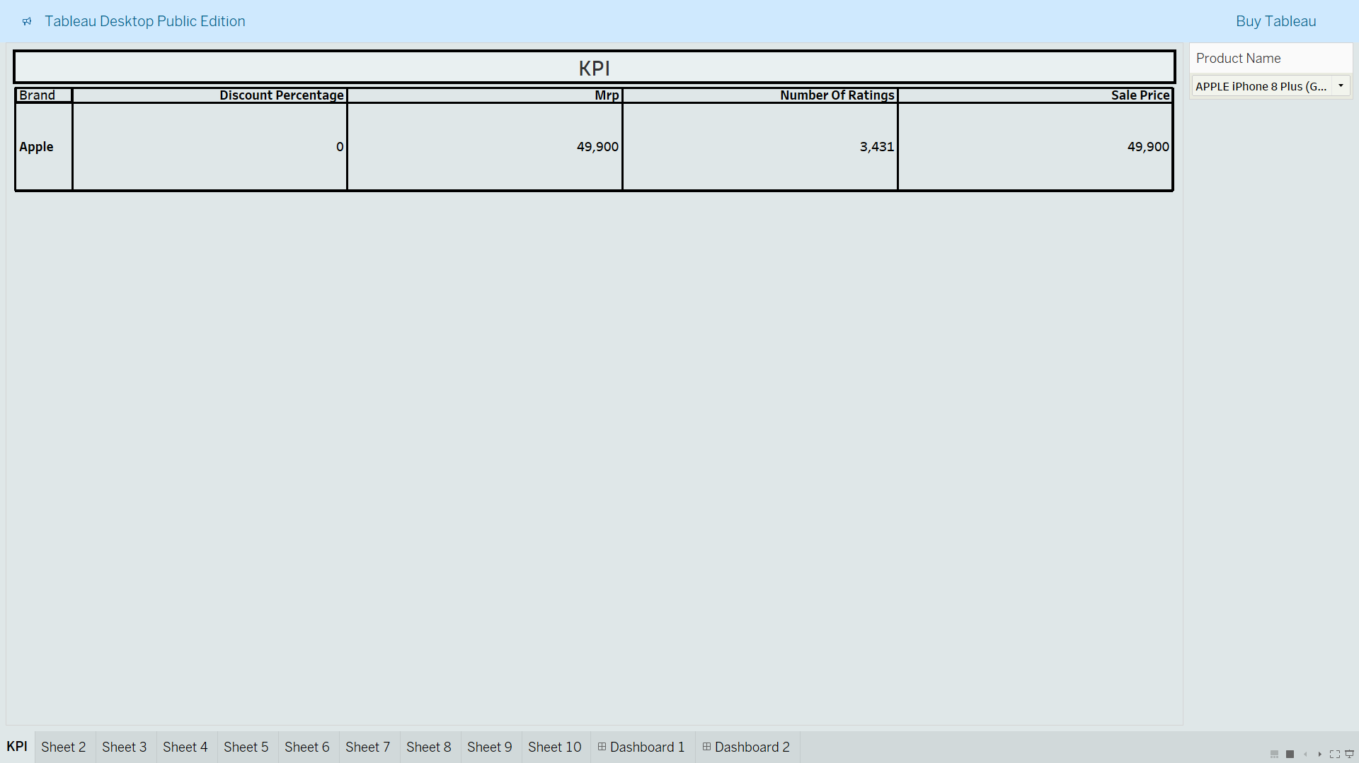

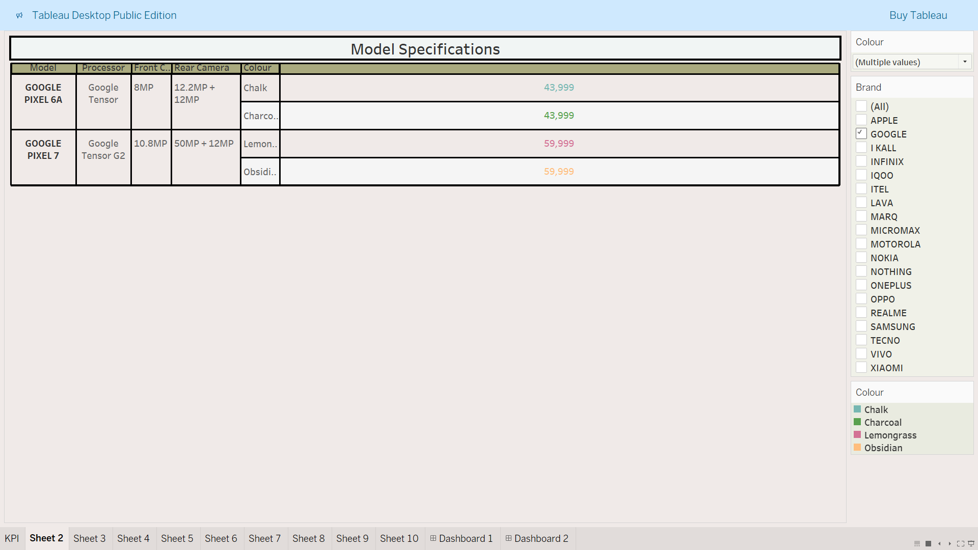

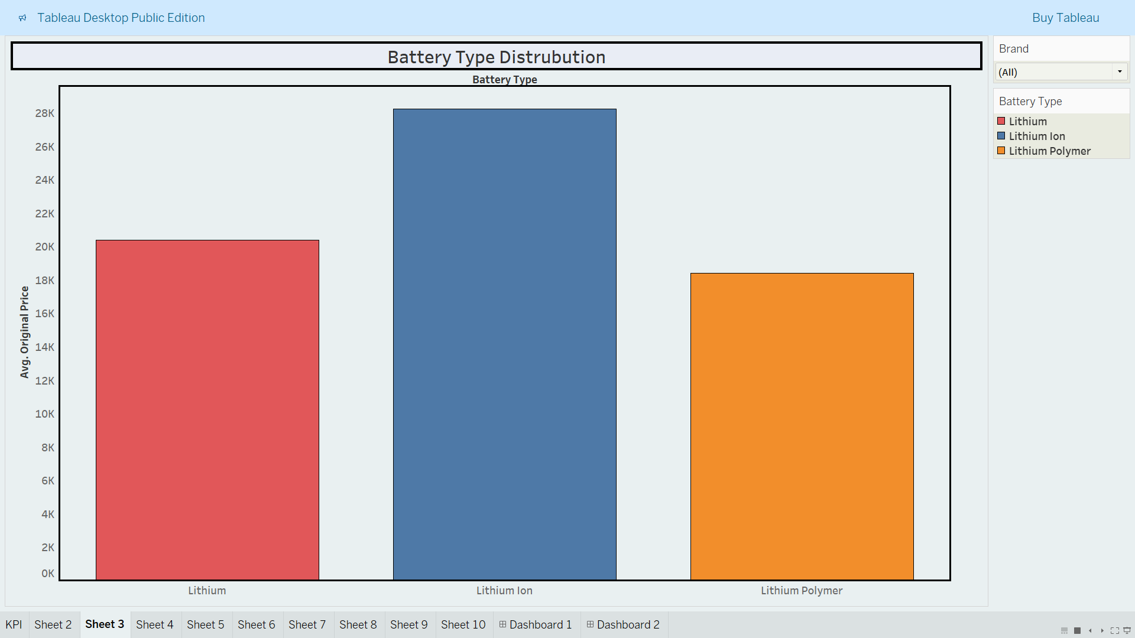

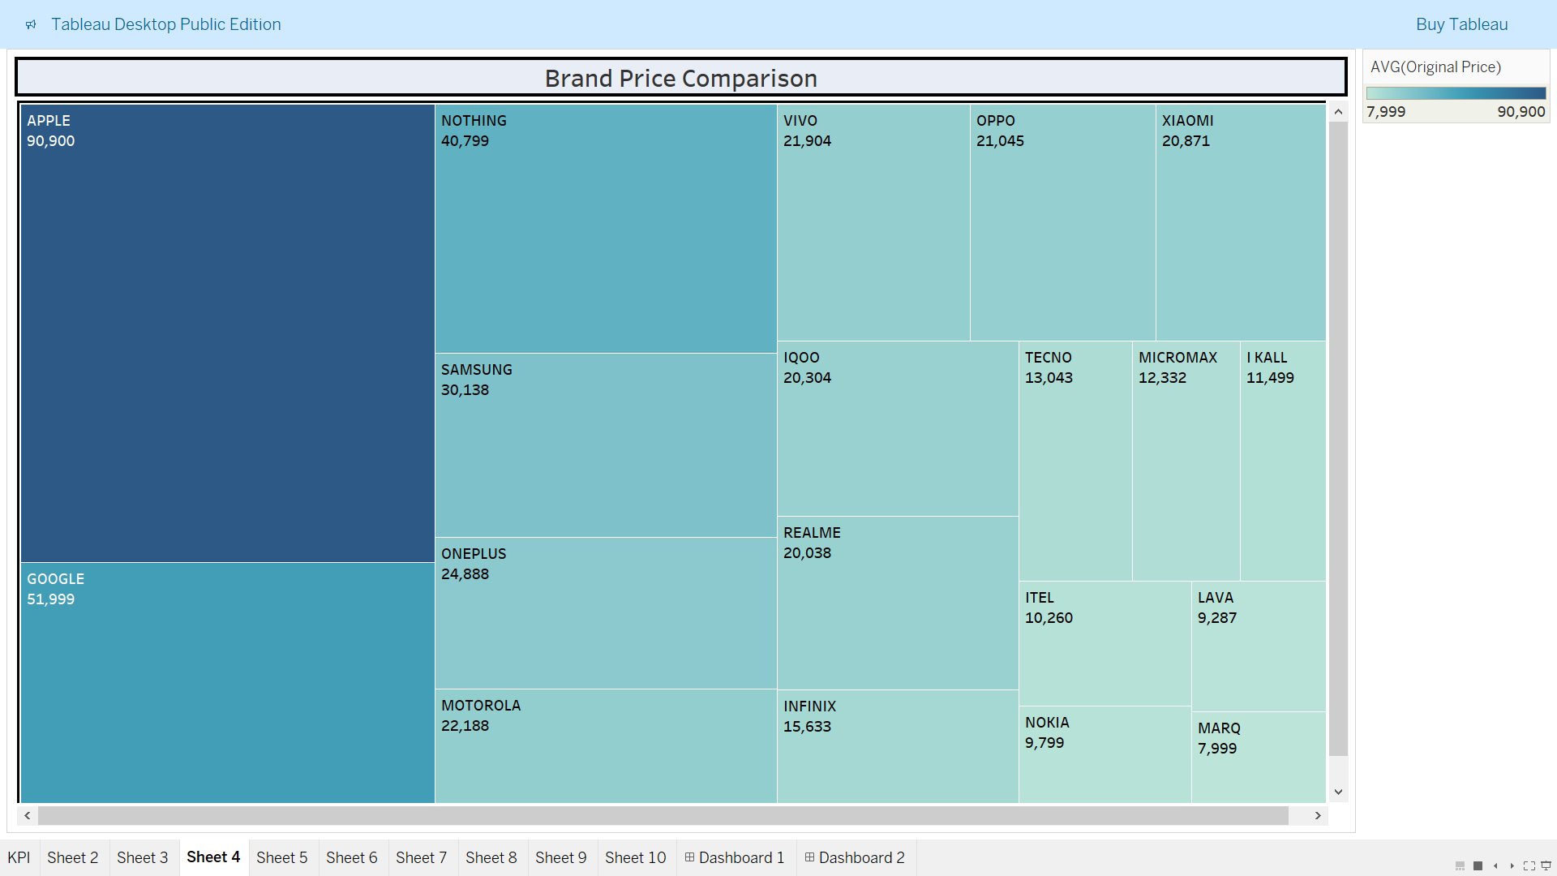

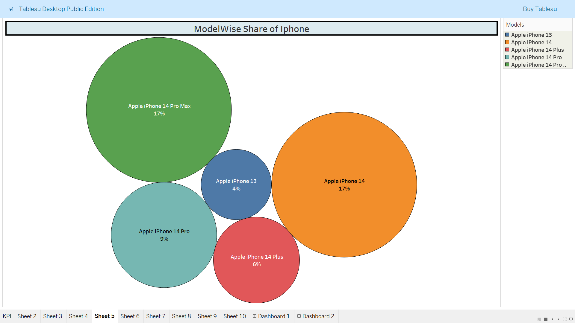

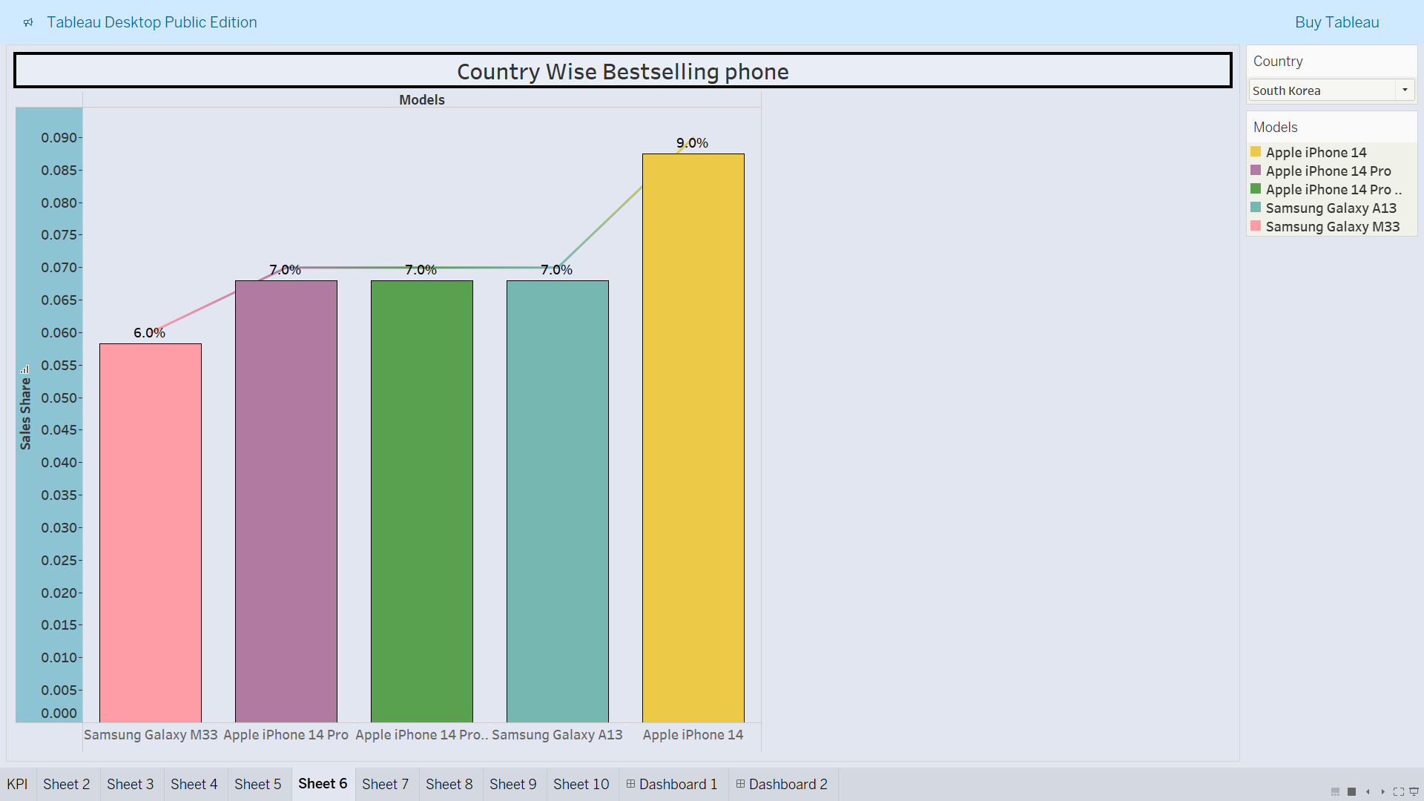

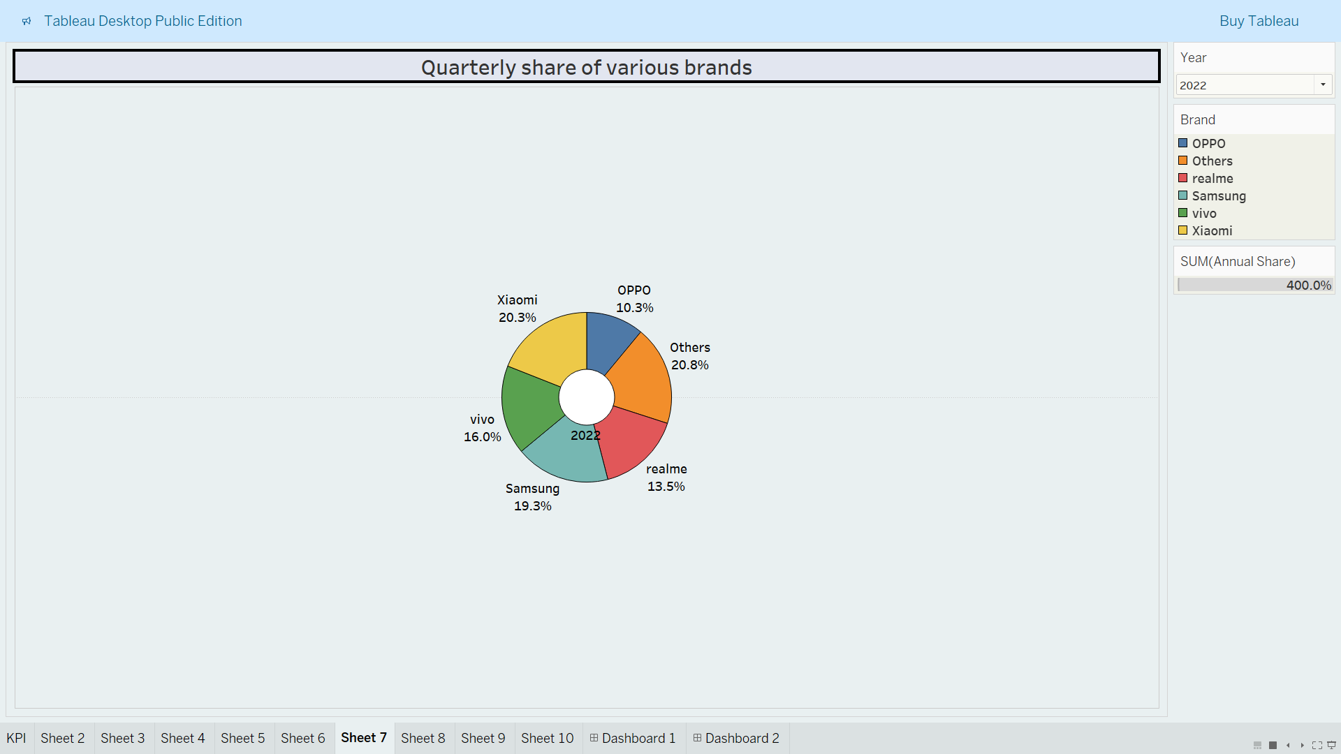

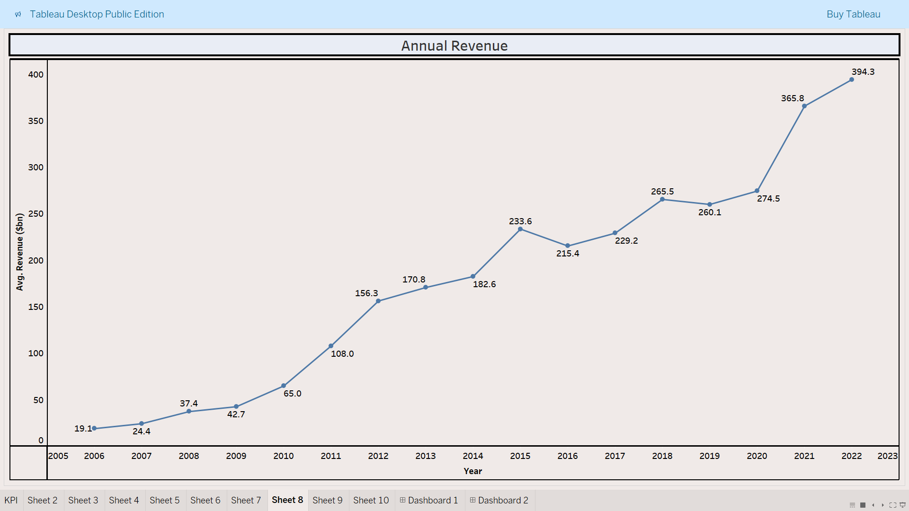

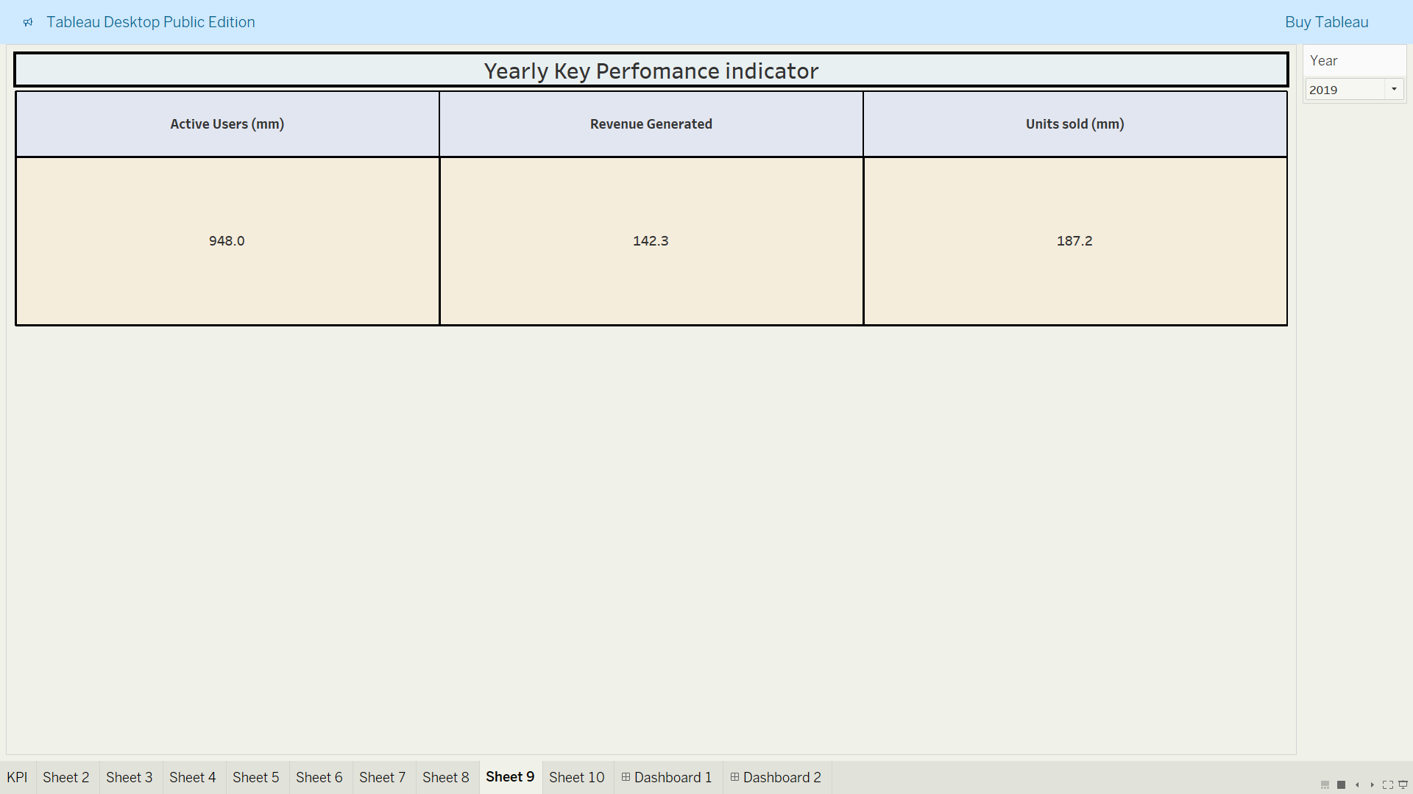

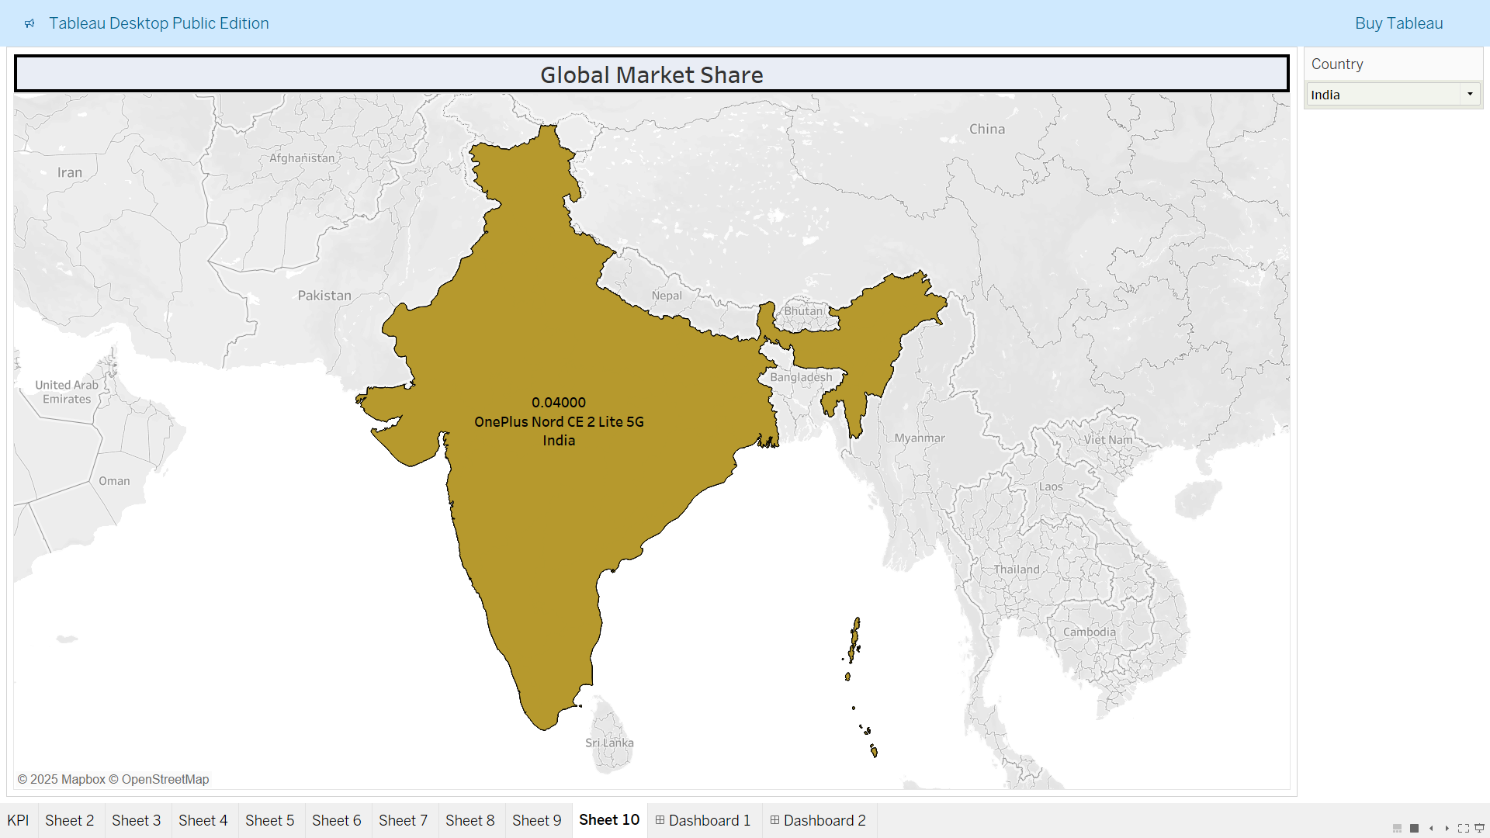

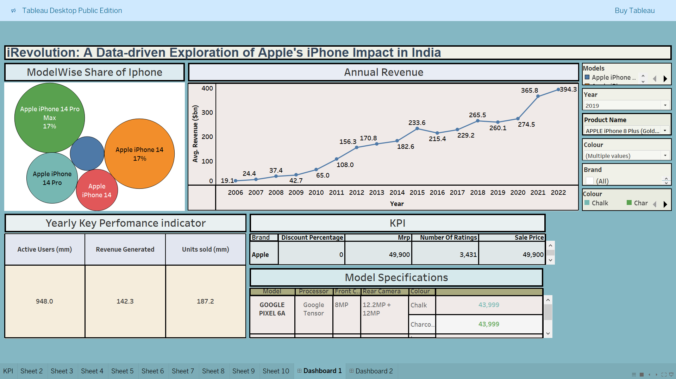

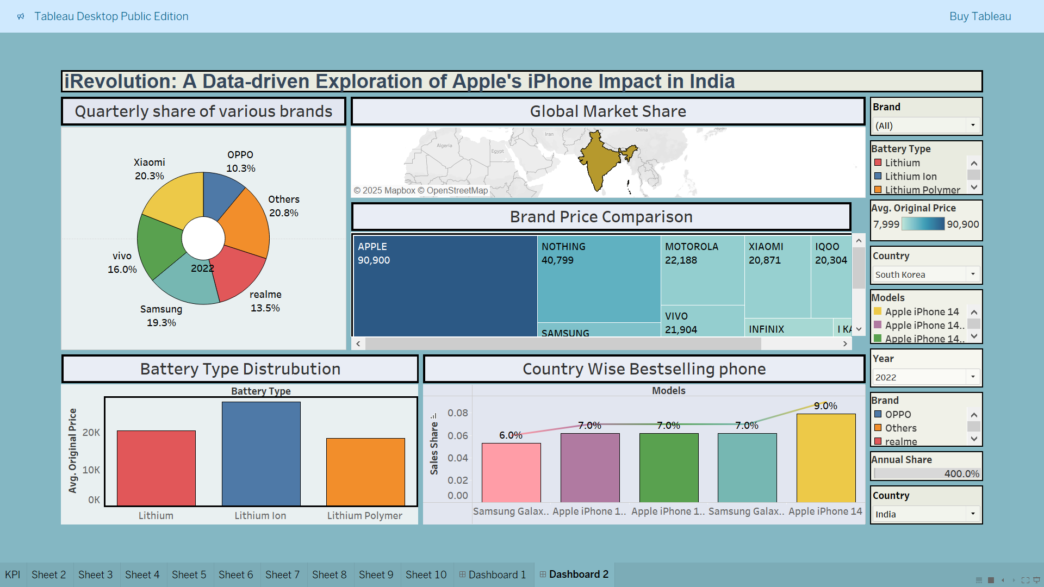

## **8. Advantages & Disadvantages**

### **Advantages:**

* Data-driven insights: Makes complex iPhone data easy to understand through visualizations.
* Interactive exploration: Users can filter by brand, model, price, specs, and more.
* Comparison-friendly: Helps users compare Apple iPhones with competing models.
* User-friendly dashboard: Clean, modern Tableau interface accessible via browser.
* No coding needed for users: Visuals are ready to use without technical knowledge**.**

### **Disadvantages:**

* Dependent on dataset quality: Accuracy depends on the quality of data collected from Flipkart/Kaggle.
* Limited real-time updates: Dashboards reflect static or batch data, not live market changes.
* Requires internet access: Full functionality depends on web connectivity for Tableau Public.

**9. Conclusion**

The *iRevolution* project successfully demonstrates how powerful data visualization tools like Tableau can convert raw smartphone data into meaningful, actionable insights. By focusing on Apple's iPhone market presence in India, the project simplifies user comparisons, reveals purchasing trends, and uncovers patterns in product popularity. The interactive dashboards and user-centric stories enhance decision-making for buyers and analysts alike.

## **10. Future Scope**

* Real-time data integration using APIs or web scraping for live pricing and reviews.
* Predictive analysis to forecast sales trends or user preference shifts.
* Mobile app integration to reach a broader audience.
* Recommendation engine to suggest the best model based on user filters.
* Multibrand expansion to include more detailed comparisons with OnePlus, Vivo, etc.

**11. APPENDIX:**

**Dataset Link:**

<https://docs.google.com/spreadsheets/d/1poFnJJdFnlLKDhmosioEPv2QcgpuJoXe/edit?usp=drive_link>

**GitHub & Project Demo Link:**

[**https://drive.google.com/file/d/18R9gZDy8trVZioeIqs2rQ8YtawDU3DRL/view?usp=drivesdk**](https://drive.google.com/file/d/18R9gZDy8trVZioeIqs2rQ8YtawDU3DRL/view?usp=drivesdk)